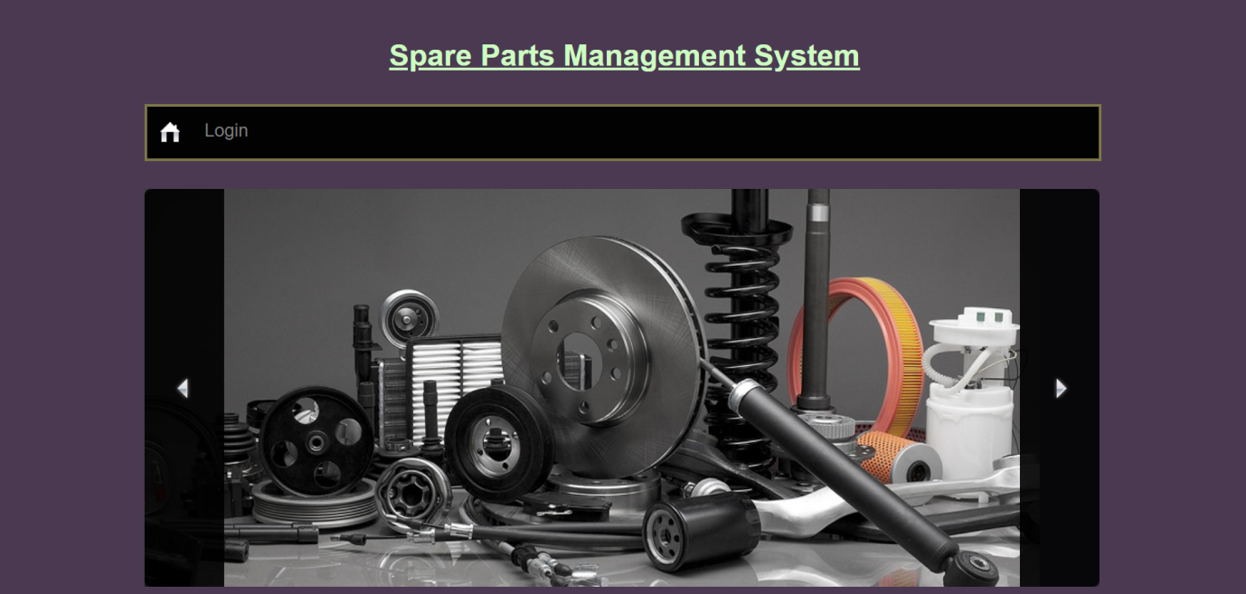

“Spare Parts Management System”

Presentation By:

**Pavan Hegde**

**Shreevathsa Hegde**

20U11064

20U11125

# Introduction 2

* “spare parts management system” project is made to purchase the spare parts in online very easily and hassle free. It provides a platform for both buyer and seller to digitally connect with each other. It removes the pain of searching for best spare parts, since all the spare parts will be available in one go

# Current Scenario 3

* Increased Adoption of Digital Solutions: With the advancement of technology and the growing need for efficient inventory management, organizations are increasingly adopting digital spare parts management systems.
* Providing several category of spare parts for the customer which is available very rarely
* Admin can adding new spare parts very easily
* Customer can login into our account and taking the benefits from our website.
* Admin will view the order and payment details so that he can easily track it.
* customer can easily view and order the spare parts through website .
* customer can make the payment in online through QR code displayed on the page

# Our Objectives 4

1. Enhance the quality of products
2. Meet the needs customer.
3. Improve the efficiency and effectiveness spare parts.
4. Improve the order and delivery service.
5. Providing the various payment option so that the customer can order and make payment easily.
6. Providing the variety of products .

# Input , Output 5

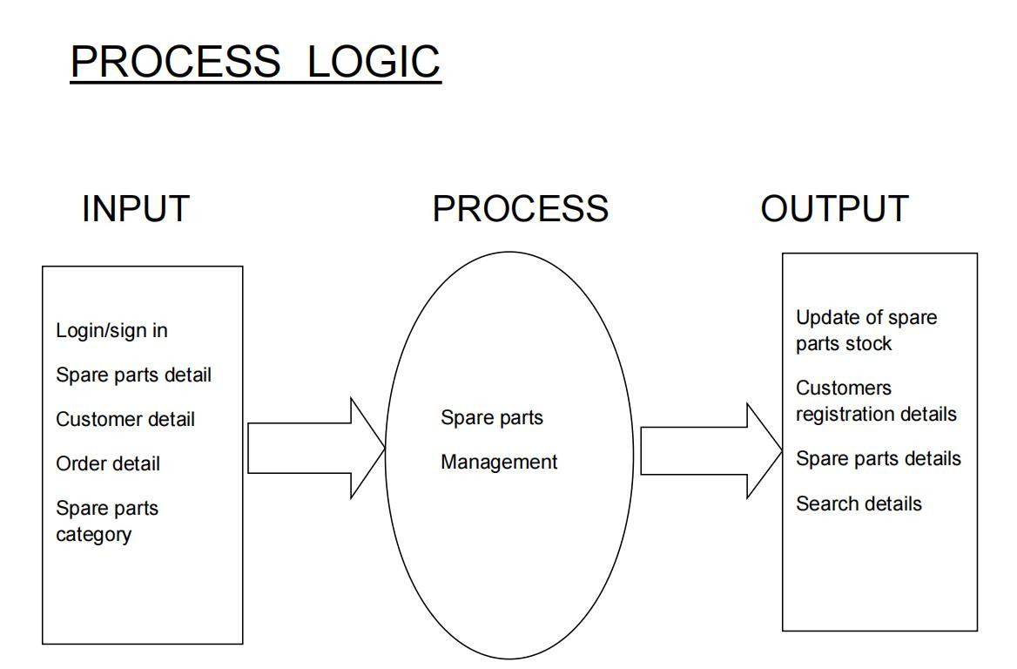

***NUMBER OF MODULES***

**6**

***Manage Different Exams***

1. **customer**

* Add personal details
* view spare parts category
* order spare parts
* make payment

## Admin

* view the customer registration
* view orderlist
* Add new spare parts
* view payment

Zero Level DFD

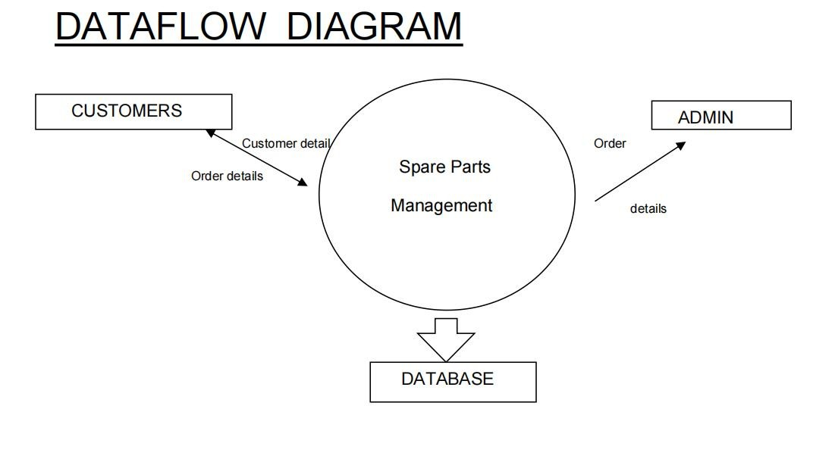

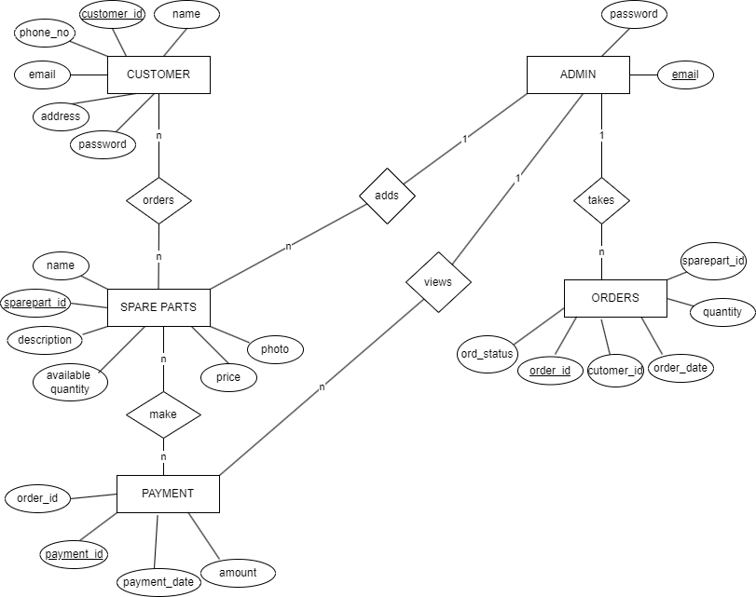

**ER- Diagram**

# Mock-ups 9

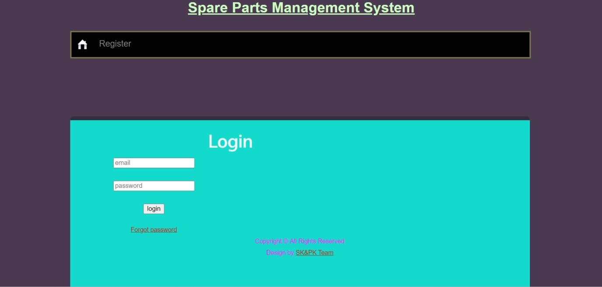

* 1. Login Page

# Mock-ups 10

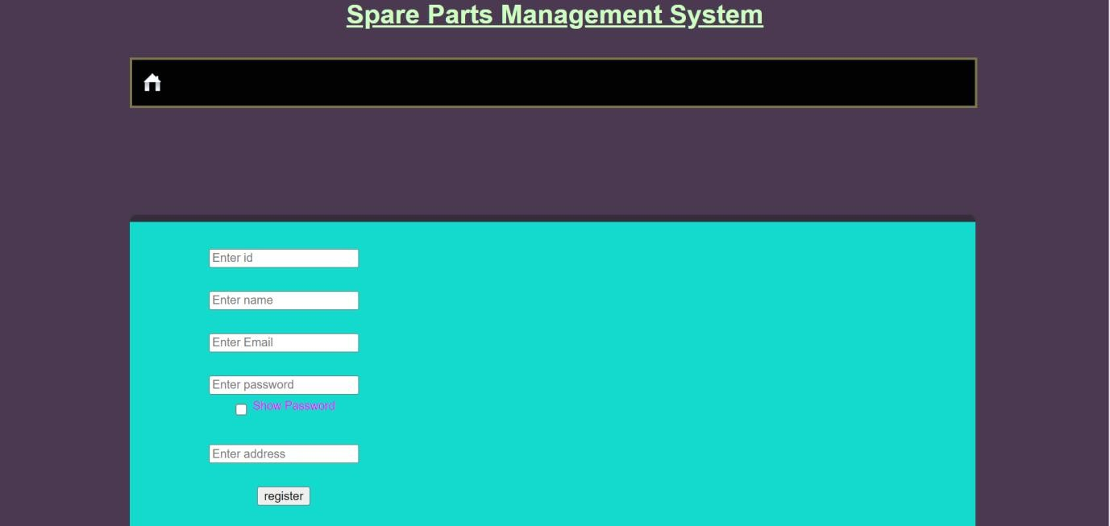

* 1. Signup page

# Hardware Requirements 11

1. Processor : Intel Core i3 and above
2. RAM : 2GB or more
3. Hard disk : 128GB or more
4. Operating System : Windows 7 and above

# Software Requirements 12

Front End : HTML , CSS , JavaScript ,Python

Backend : Python django Database : MySQL

# Tools 13

Code Editor : PyCharm Browser : Google Chrome Server : XAMPP

# Limitations 14

* Only admin can post the Different spare parts.
* Shipment will take longer time.
* Customer should login our website to access the contents.

# Scope of the Project 15

* Variety of spare parts will be added in the future.

.

* various payment option will added.
* shipping will be done fast.
* Add to cart system will be implemented in future.





**16**